Oracle Deployment, Testing & Documentation Report
Author: Group 1
Date: November 2025

Instance & Environment Setup
This establishes the Oracle environment by preparing the instance, configuring tablespaces, setting parameters, and demonstrating startup/shutdown. It ensures the database is properly initialized and ready for subsequent configuration.
Instance Lifecycle
The database instance was started and shut down to confirm proper lifecycle management. Screenshots capture the successful startup message and the immediate shutdown sequence, showing that the system responds correctly to lifecycle commands.
Tablespace Configuration
A dedicated tablespace was created to store user data. The tablespace was configured with auto-extend options to ensure scalability. Screenshots show the creation of the tablespace and its assignment as the default for the ADMIN user. Validation queries confirm the tablespace is online and available.
Parameter Management
Initialization parameters were reviewed to check system defaults (such as block size and process limits). One parameter was modified to increase the number of allowed processes, followed by a restart of the instance to apply changes. Screenshots show the parameter values before and after modification, demonstrating successful tuning.
Validation
Queries were carried out to confirm:
- The instance status is OPEN.
- The newly created tablespace is ONLINE.
- The updated parameter values are reflected in the system.
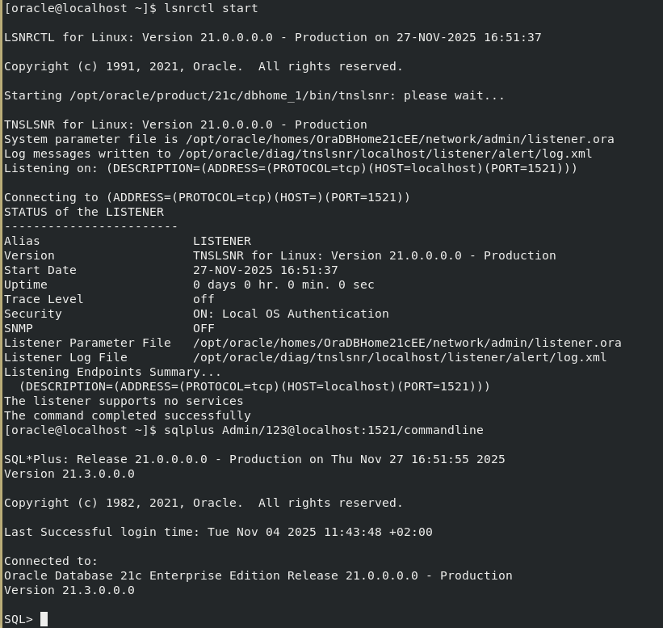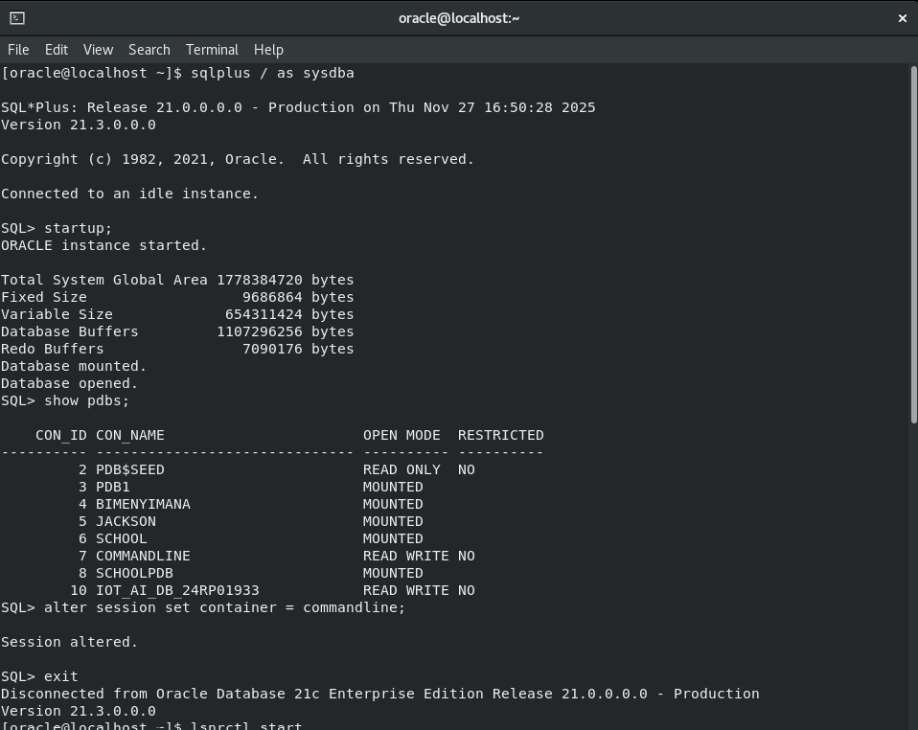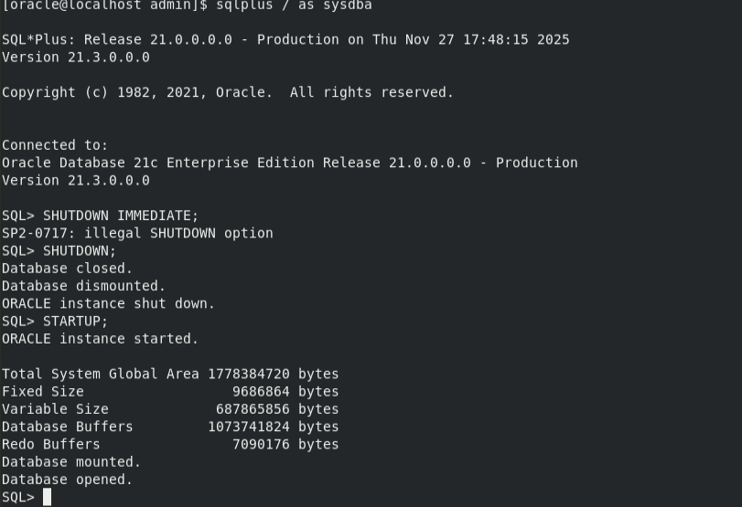
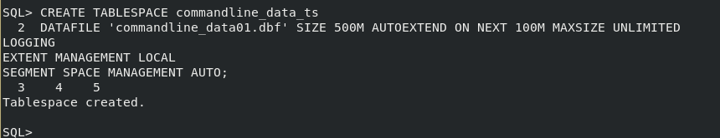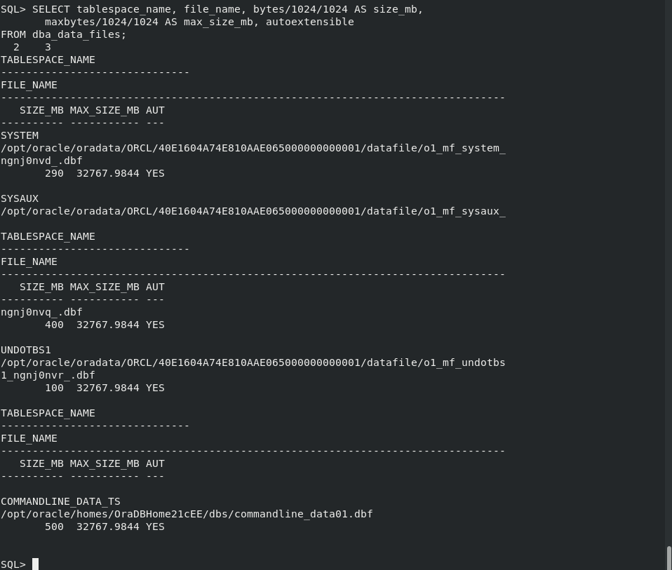

User, Role, and Profile Administration

This establishes the foundation for secure access control in the Oracle database. It demonstrates how users are created, how roles are defined to group privileges, and how profiles enforce resource limits and password policies. Together, these mechanisms ensure accountability, least-privilege access, and compliance with institutional standards.
User Administration
Users represent individual accounts in the database. Each user is associated with a schema where their objects (tables, views, indexes) reside. In practice:
- New users were created with unique usernames and secure passwords.
- Default table spaces were assigned to manage storage.
- User creation and assignment of default tablespace.
- Query showing the list of users in the database.
Role Administration
Roles simplify privilege management by grouping multiple permissions into a single entity. In practice:
- Roles such as DBA, AUDITOR, and TRAINEE were created.
- Privileges (e.g., SELECT, INSERT, UPDATE) were granted roles.
- Roles were then assigned to users, ensuring consistent access control.
Profile Administration
Profiles enforce resource limits and password policies. They help prevent abuse and ensure compliance. In practice:
- Profiles were created with limits on sessions, CPU time, and idle time.
- Password policies were defined (expiry, complexity, reuse).
- Profiles were assigned to users to enforce these rules.
Privilege Management
Privileges control what actions users can perform. In practice:
- System privileges (e.g., CREATE SESSION, CREATE TABLE) were granted to allow basic operations.
- Object privileges (e.g., SELECT ON users, INSERT ON user_logs) were granted for controlled access to specific tables.
- Privileges were revoked when no longer needed, ensuring least-privilege access.
- Query from DBA_TAB_PRIVS showing privilege assignments.
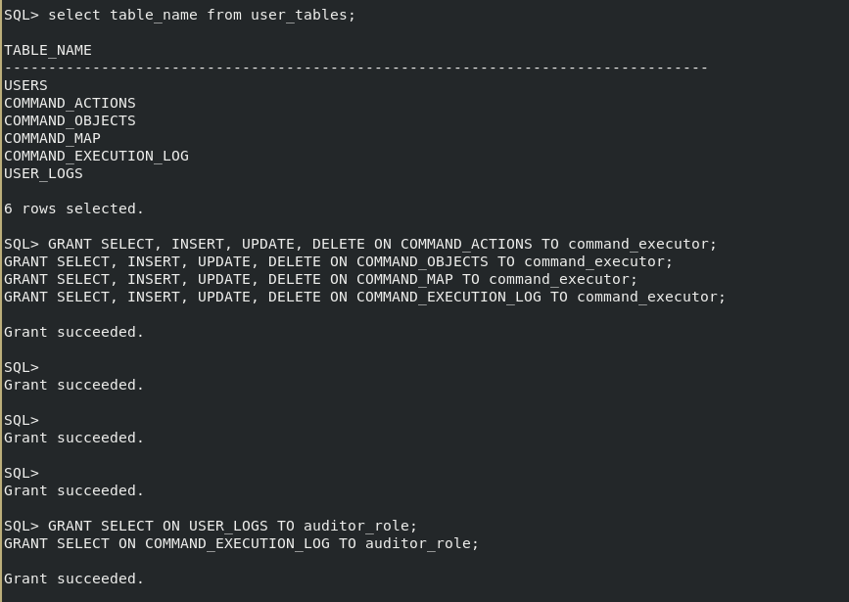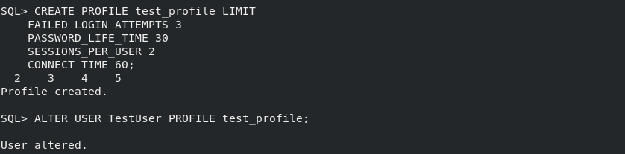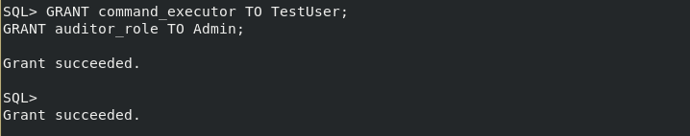

Security & Encryption

This demonstrates how Oracle secures sensitive data through encryption technologies, Transparent Data Encryption (TDE), and wallet management. It also covers the use of synonyms to simplify secure object access. Together, these mechanisms ensure confidentiality, controlled access, and compliance with institutional security standards.
Encryption
Oracle provides multiple layers of encryption to protect data at rest and in transit.
- Sensitive columns such as passwords or personal identifiers can be encrypted to prevent unauthorized disclosure.
- Network encryption ensures secure communication between clients and the database.
- Screenshots capture the configuration of encryption settings and validation queries showing encrypted data storage.
Transparent Data Encryption (TDE)
TDE automatically encrypts data stored in tablespaces without requiring application changes.
- A master key is created and stored securely in the Oracle Wallet.
- Tablespaces or specific columns are encrypted transparently.
- Screenshots show the creation of the TDE master key, enabling encryption, and queries confirming encrypted tablespaces.
Wallet Management
The Oracle Wallet securely stores encryption keys and credentials.
- A wallet was created and opened to manage TDE keys.
- Errors encountered during wallet creation and privilege assignment were documented and resolved.
- Screenshots show wallet creation, opening, and successful usage in encryption operations.
Synonyms
Synonyms provide secure and simplified access to objects.
- Public synonyms allow controlled access to shared objects without exposing schema names.
- Private synonyms simplify references for individual users.
- Screenshots demonstrate synonym creation and usage, showing how they streamline secure object access.
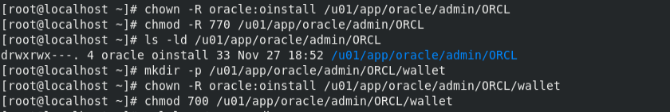
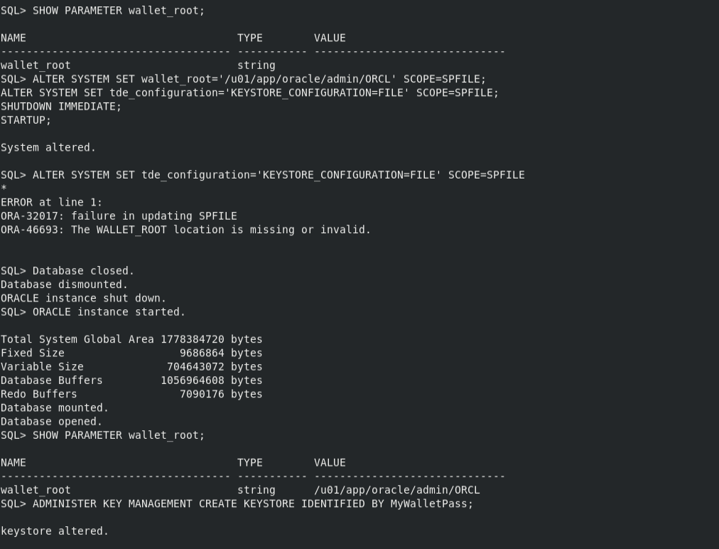
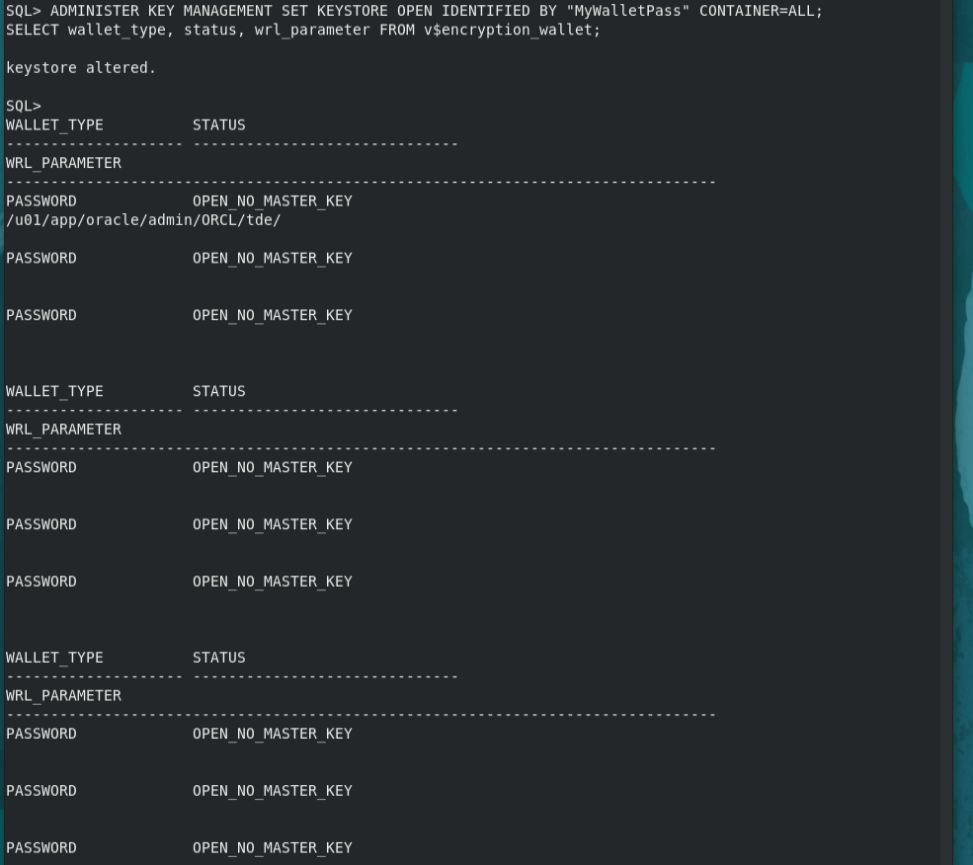
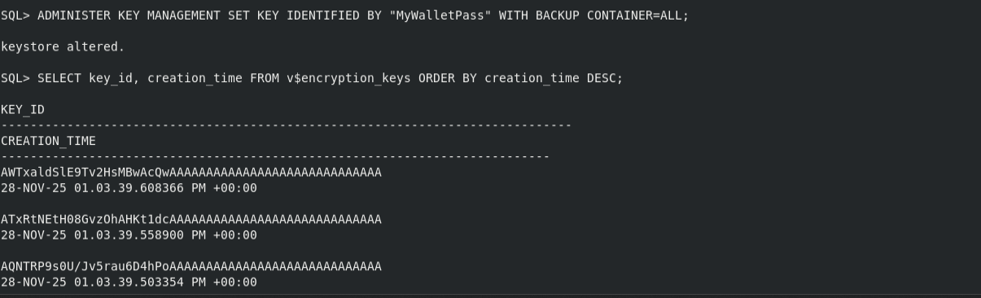
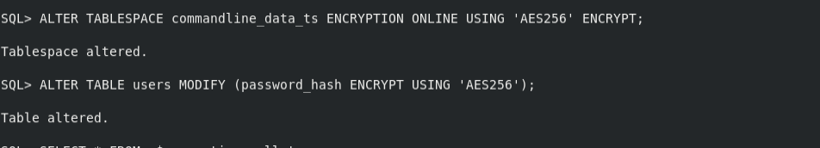
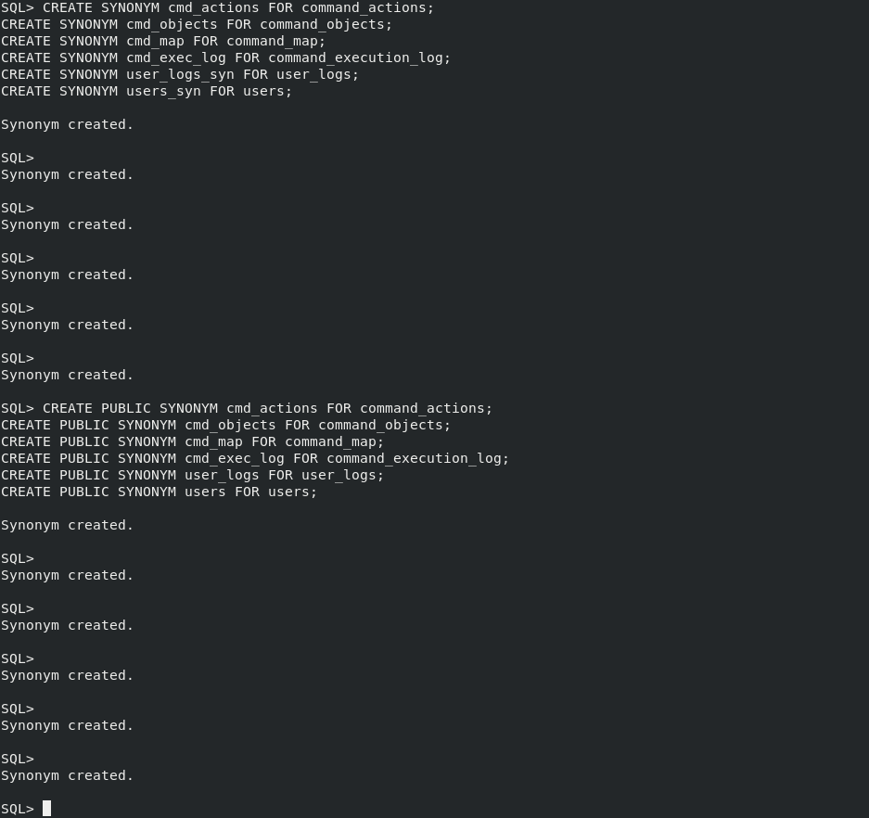
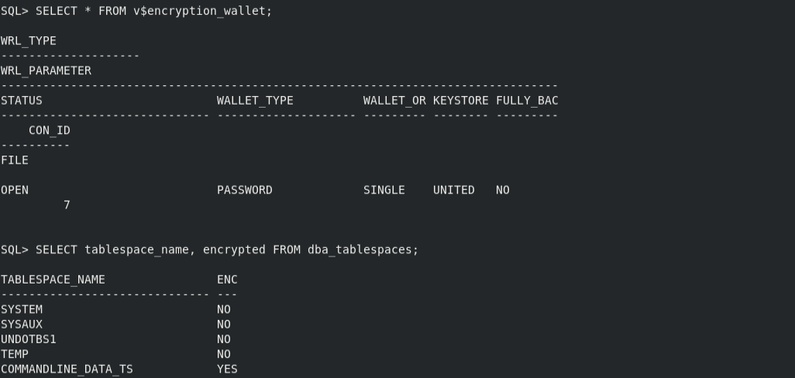

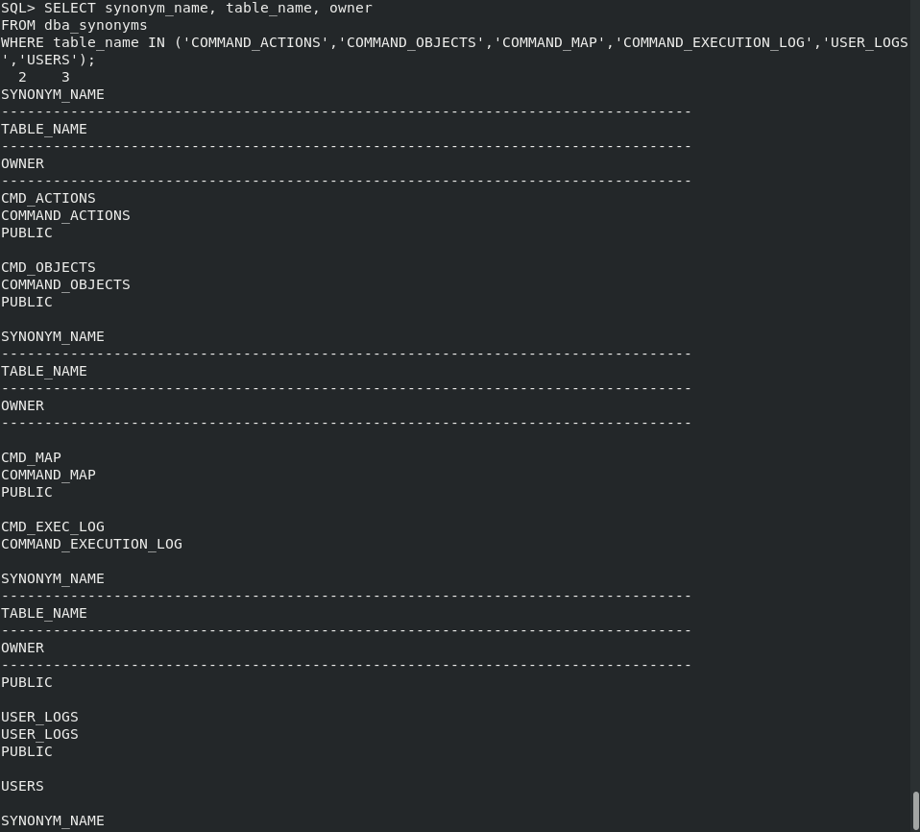
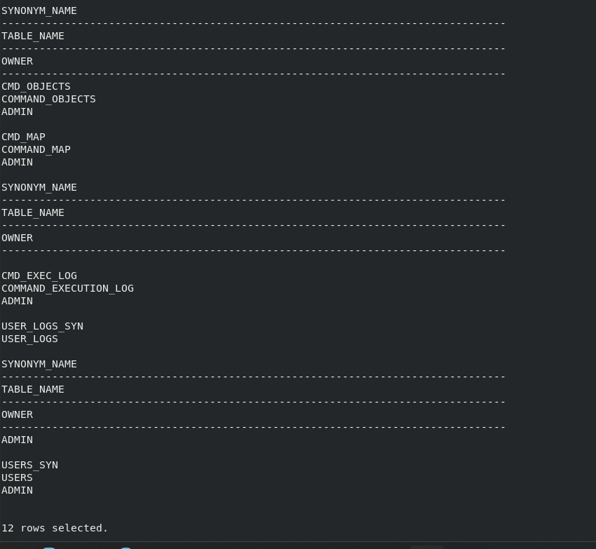
Auditing & Logging

This demonstrates how Oracle ensures accountability by recording user actions and system events. Auditing and logging provide a trail of evidence that can be used for compliance, troubleshooting, and security investigations.
Audit Trail
The audit trail captures critical events such as login, privilege usage, and schema changes.
- Standard auditing was enabled to track session activity.
- Specific actions (e.g., CREATE TABLE, DROP USER) were audited to ensure accountability.
- Screenshots show audit trail queries listing user activities and timestamps.
Log Tables
Custom log tables were created to capture application-level events.
- The USER_LOGS table records login attempts, updates, and deletions.
- Each log entry includes the user ID, event type, event detail, status, and timestamp.
- Screenshots demonstrate failed inserts due to foreign key enforcement, followed by successful inserts once valid users were referenced.
- Queries joining USERS and USER_LOGS confirm the linkage between users and their activities.
Accountability
Auditing and logging ensure that every action is tied to a specific user.
- Failed login attempts are recorded for security monitoring.
- Successful operations are logged for traceability.
- Privilege usage is tracked to prevent unauthorized access.
- Screenshots highlight accountability queries showing which user performed which action, when, and whether it succeeded or failed.
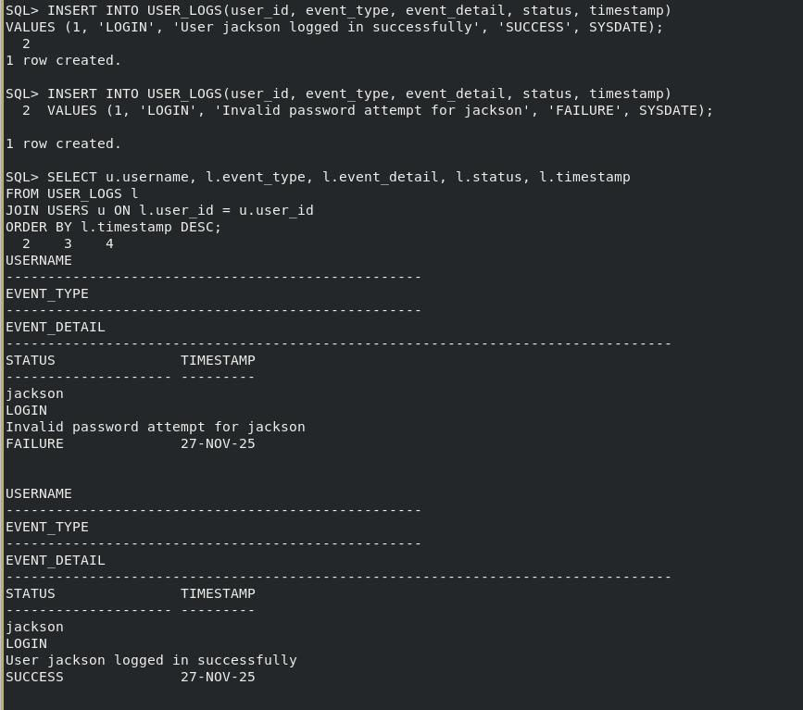
Backup & Recovery

This demonstrates how Oracle ensures data resilience through physical and logical backups. It covers RMAN for database-level protection, Data Pump for schema/table exports, and recovery validation to prove that backups can be restored successfully. Together, these practices guarantee that the institution can recover from failures or accidental data loss.
RMAN Backups
Oracle Recovery Manager (RMAN) provides comprehensive backup and recovery capabilities.
- Full database backups were performed, including archived logs to ensure point-in-time recovery.
- Validation checks confirmed that backup pieces were usable and free of corruption.
- Screenshots show RMAN backup execution and validation output, highlighting successful completion messages.
Data Pump Exports
Data Pump was used for logical backups of schemas and tables.
- Export jobs created dump files and logs in the designated directory object.
- Specific tables such as USERS and USER_LOGS were exported to demonstrate selective backup.
- Screenshots capture the export job logs, showing successful completion and dump file creation.
Recovery Validation
Backups are only meaningful if they can be restored. Recovery validation was performed in two ways:
- RMAN Validation: The VALIDATE DATABASE command confirmed that all blocks could be restored without corruption.
- Data Pump Import: Dump files were imported into a test schema to verify usability. Row counts and audit trail queries confirmed that restored data matched the original.
- Screenshots show import logs with “Job successfully completed” and validation queries comparing row counts before and after recovery.
- Accountability
- Recovery validation ensures that backups are not only taken but tested. This provides confidence that the institution can recover from unexpected failures. Documenting errors (such as invalid directory references or schema mismatches) and their resolutions demonstrate troubleshooting capability and strengthens institutional learning.
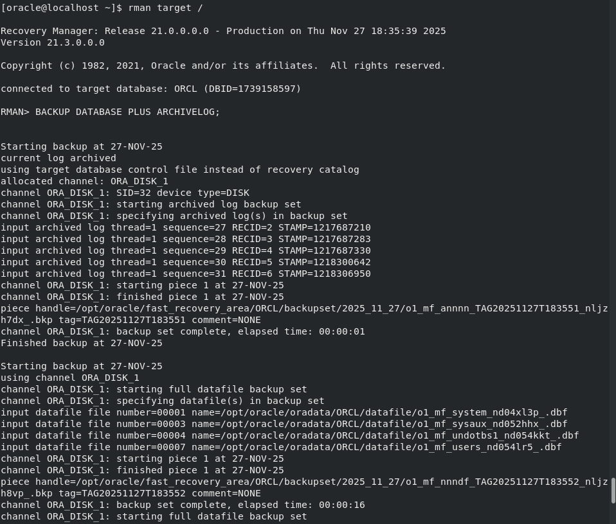
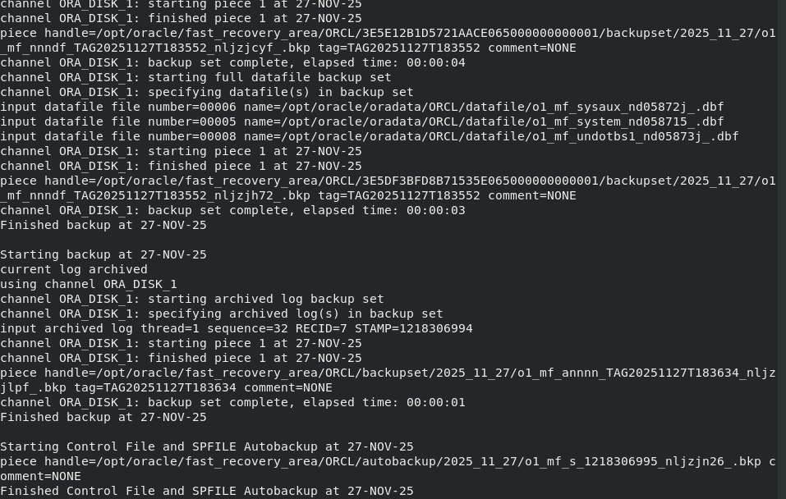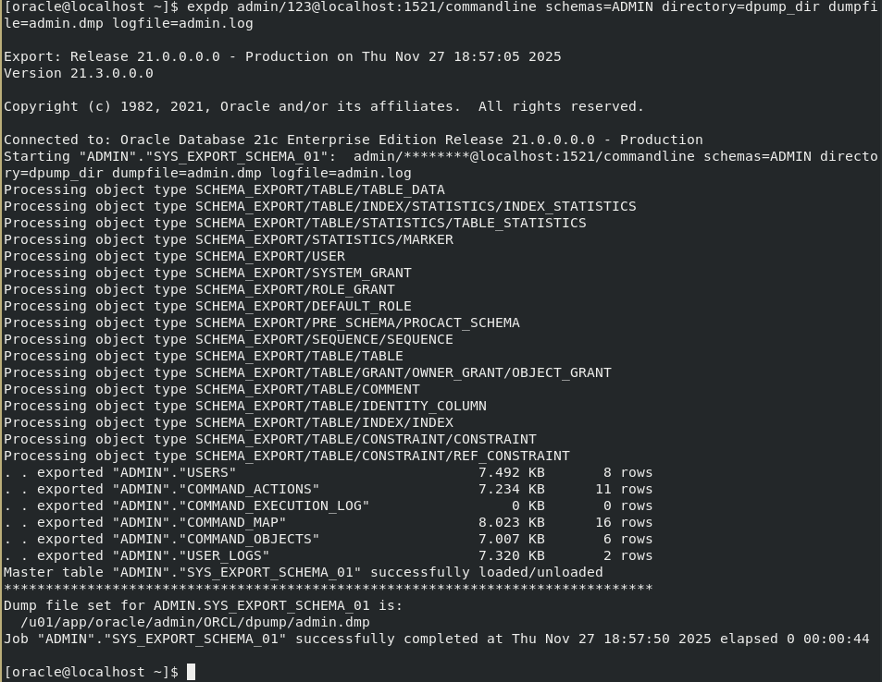
Performance Monitoring

This demonstrates how Oracle provides visibility into health and performance systems. Monitoring ensures that administrators can detect issues early, optimize resource usage, and maintain database stability. The focus is on dynamic performance views (V$ views), alert logs, and space monitoring.
V$ Views
Oracle’s dynamic performance views expose real-time information about the instance.
- Session Monitoring: Views such as V$SESSION provide details about connected users, their status, and activity.
- SQL Monitoring: Views like V$SQL show recent SQL statements, execution counts, and elapsed times.
- Wait Events: Views such as V$SYSTEM_EVENT highlight bottlenecks by listing events and time waited.
- Screenshots should capture queries against these views, showing active sessions, SQL activity, and wait statistics.
Alert Logs
The alert log records critical events and errors.
- It includes startup/shutdown messages, ORA errors, and background process information.
- Monitoring the alert log helps administrators quickly identify problems such as failed jobs or space issues.
- Screenshots should show the alert log being tailed in real time, highlighting recent entries and error messages if any occurred.
Space Monitoring
Space usage is a critical aspect of performance.
- Tablespace Usage: Queries against DBA_DATA_FILES and DBA_FREE_SPACE confirm available and used space.
- Segment Monitoring: Views such as DBA_SEGMENTS identify large objects consuming storage.
- Quota Management: DBA_TS_QUOTAS shows user quotas and usage limits.
- Screenshots should capture tablespace usage queries, free space listings, and segment size reports.
Accountability
Performance monitoring ensures that administrators can proactively detect and resolve issues.
- V$ views provide real-time visibility into sessions and SQL execution.
- Alert logs capture system-level events for troubleshooting.
- Space monitoring prevents outages due to exhaust storage.
- Together, these tools provide a comprehensive view of database health.
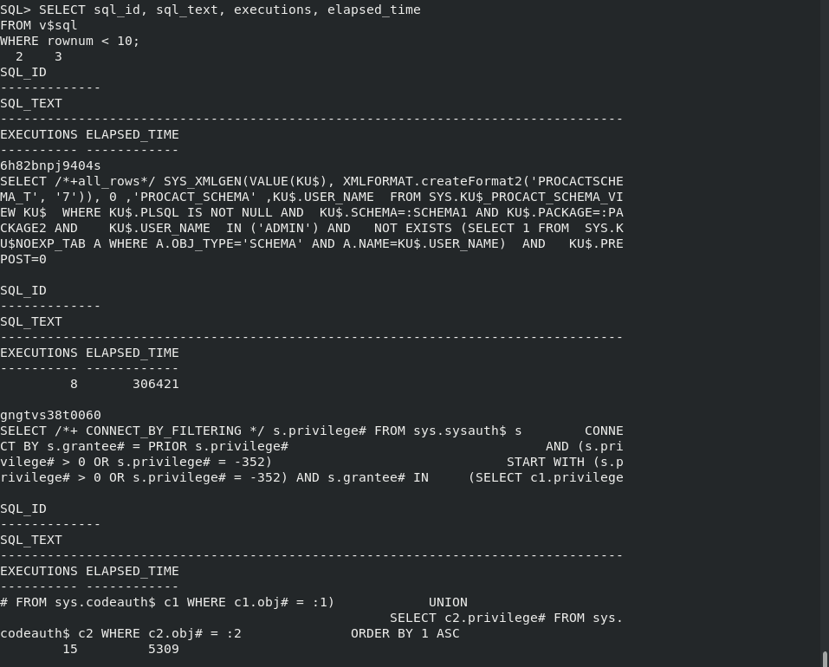
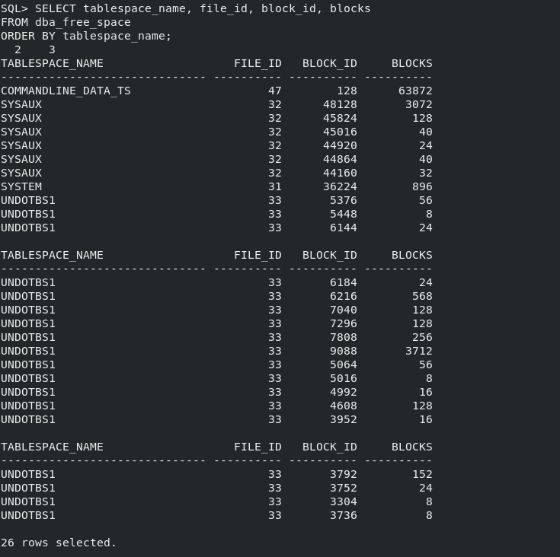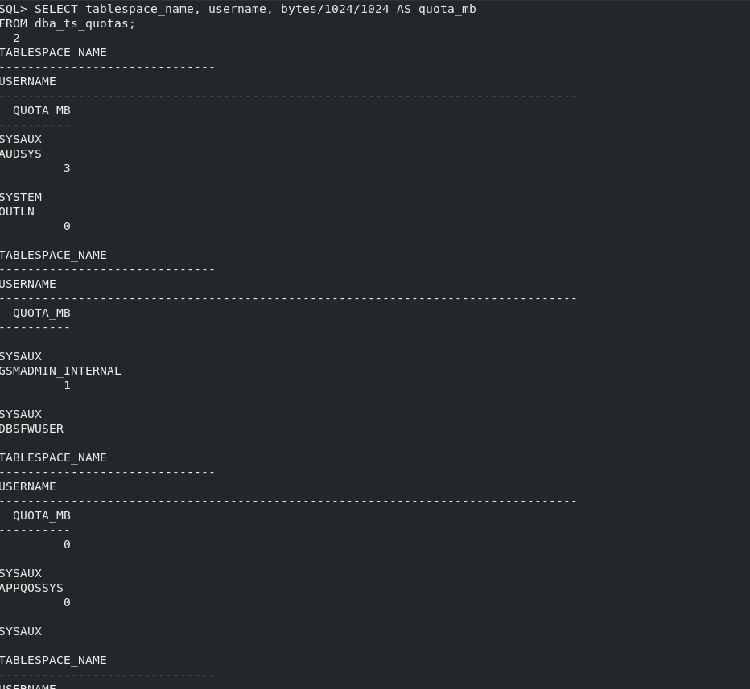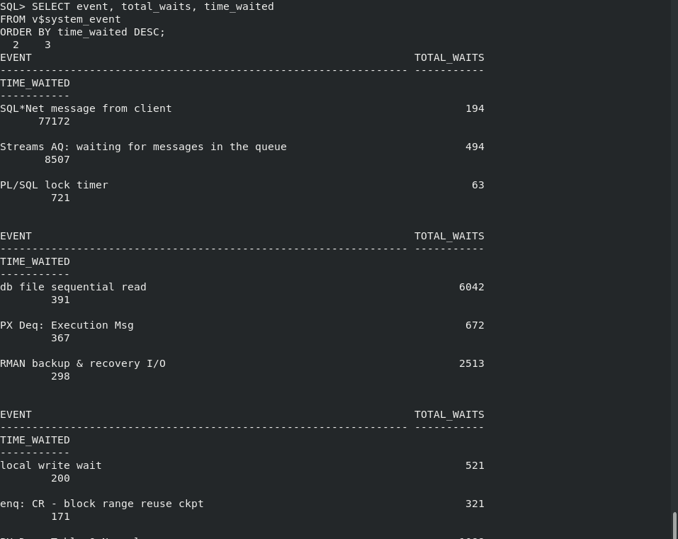
📑 Schema & Object Administration

This demonstrates how Oracle manages database structures and enforces access control. It covers the creation and administration of tables, indexes, and views, as well as the assignment of object privileges. These elements form the backbone of schema design, performance optimization, and secure data access.
Tables
Tables are the fundamental storage objects in Oracle.
- New tables were created to store user information and activity logs.
- Constraints such as primary keys, unique keys, and foreign keys were applied to enforce data integrity.
- Alterations were made to add new columns when requirements changed.
- Screenshots should capture table creation, alteration, and validation queries showing structure and constraints.
Indexes
Indexes improve query performance by allowing faster lookups.
- Indexes were created on frequently queried columns such as usernames.
- Redundant or unused indexes were dropped to optimize storage and performance.
- Screenshots should show index creation and queries from the data dictionary confirming their existence.
Views
Views provide simplified and secure access to data.
- Logical views were created to expose only relevant columns, such as active users.
- Views were queried to demonstrate how they abstract underlying table complexity.
- Screenshots should capture view creation and query results showing filtered data.
Object Privileges
Object privileges control access to specific tables, views, or indexes.
- Privileges such as SELECT, INSERT, and UPDATE were granted to specific users or roles.
- Privileges were revoked when no longer needed, enforcing least-privilege access.
- Roles were used to group privileges and assign them consistently.
- Screenshots should capture privilege grants, revokes, and queries from the data dictionary showing privilege assignments.
Accountability
Schema and object administration ensures that:
- Data structures are well-organized and optimized.
- Performance is improved through indexing.
- Access is simplified and controlled via views.
- Security is enforced through object privileges.
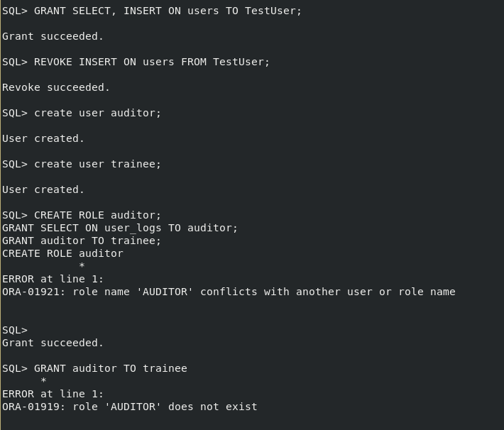
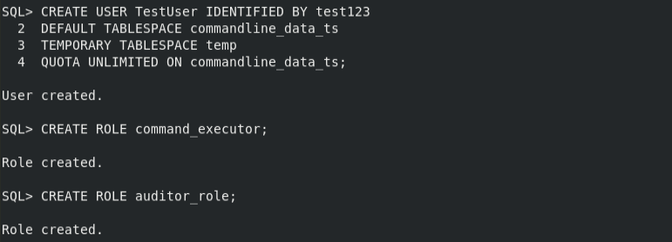
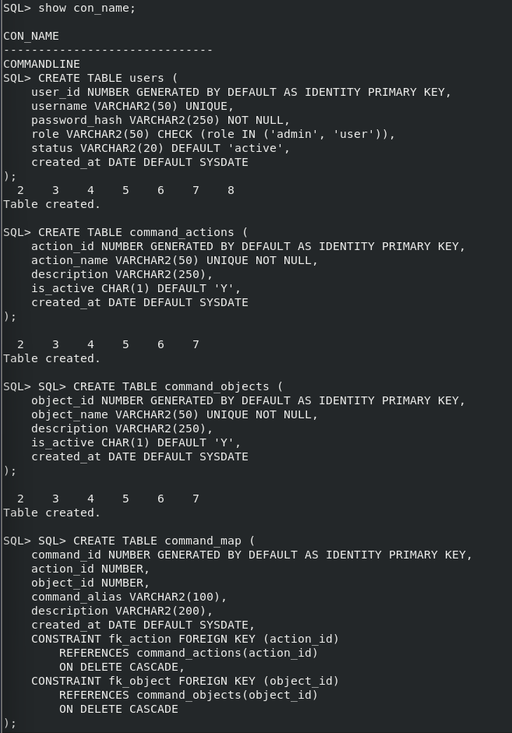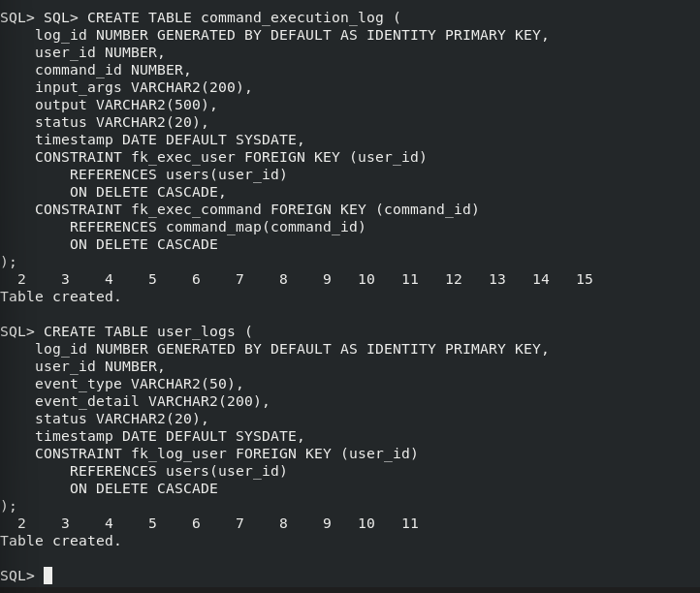
📑 Data Consistency & Recovery Testing

This validates that the Oracle database maintains transactional integrity and can recover from accidental changes or failures. It demonstrates how transactions enforce consistency, how flashback features restore past states, and how validation queries confirm data accuracy. Together, these practices prove the system’s resilience and reliability.
Transactions
Transactions ensure that database operations follow the ACID principles (Atomicity, Consistency, Isolation, Durability).
- Insert and update operations were tested with commit to permanently save changes.
- Rollback was used to undo unintended modifications, restoring the database to its previous state.
- Savepoints were applied to allow partial rollbacks within a transaction.
- Screenshots should capture transaction execution, rollback in action, and queries confirming the restored state.
Flashback Features
Oracle’s flashback technology allows administrators to view or restore past versions of data.
- Flashback Query was used to retrieve historical data as of a specific timestamp.
- Flashback Table restored a table to its state before accidental updates.
- Flashback Drop recovered a table that had been dropped, using the recycle bin.
- Screenshots should show flashback queries, table recovery, and confirmation of restored data.
Validation
Validation ensures that recovered data matches expectations.
- Row counts were compared before and after recovery to confirm consistency.
- Audit trail queries verified that user actions were correctly logged and linked to restored data.
- Integrity checks confirmed that relationships between tables remained intact after recovery.
- Screenshots should capture row count comparisons, audit trail queries, and consistency checks.
Accountability
Data consistency and recovery testing prove that:
- Transactions protect against accidental or partial changes.
- Flashback features provide rapid recovery from user errors.
- Validation queries confirm that restored data is accurate and complete.
- Together, these mechanisms ensure institutional resilience and compliance with best practices.
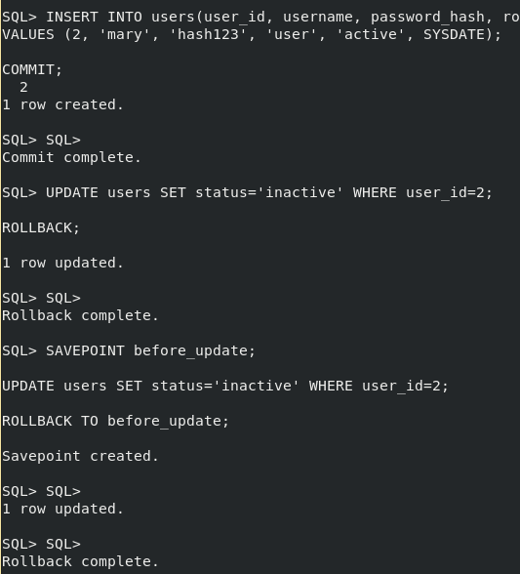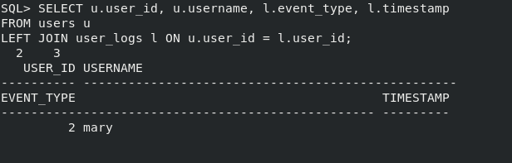
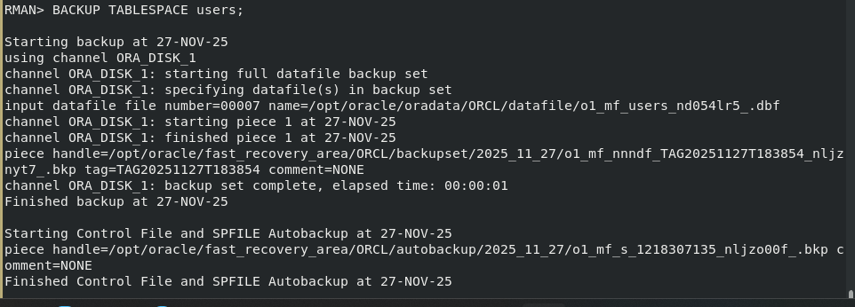
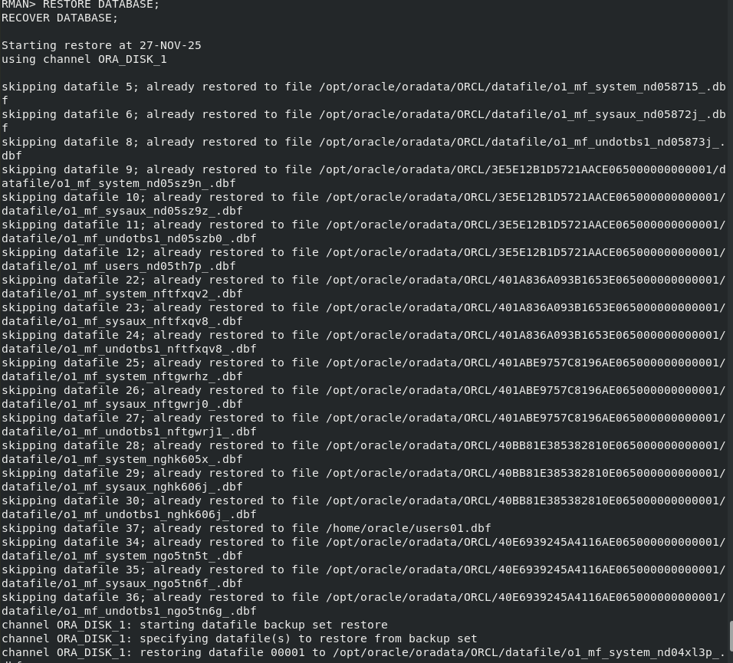

Conclusion
This report has documented the complete deployment, testing, and validation of Oracle Database 21c (commandline). Each addressed a critical aspect of database administration, from instance setup to data consistency testing, ensuring that the environment is secure, resilient, and reproducible.
Key Achievements
- Instance & Environment Setup: Established a stable foundation with configured tablespaces and tuned parameters.
- User, Role, and Profile Administration: Implemented secure access control with users, roles, and profiles enforcing least-privilege principles.
- Security & Encryption: Protected sensitive data using Transparent Data Encryption (TDE), wallet management, and synonyms for secure access.
- Auditing & Logging: Ensured accountability by capturing user actions in audit trails and custom log tables.
- Backup & Recovery: Demonstrated resilience through RMAN backups, Data Pump exports, and recovery validation.
- Performance Monitoring: Provided visibility into system health using V$ views, alert logs, and space monitoring.
- Schema & Object Administration: Managed tables, indexes, views, and privileges to optimize performance and enforce security.
- Data Consistency & Recovery Testing: Validated transactional integrity and recovery capabilities using rollback, flashback, and validation queries.
Accountability & Troubleshooting
Errors encountered during testing (e.g., ORA-02291, ORA-01017, ORA-39170) were documented with their resolutions.
Reproducibility
The report emphasizes step-by-step reproducibility. Colleagues can follow the documented procedures and screenshots to independently set up, monitor, and recover the database environment without requiring deep Oracle expertise.

